GENDER PAY GAP
20 21

PAY DATA

GENDER PAY GAP
46.2%
MEDIAN GENDER PAY GAP
25.7%
MEAN GENDER PAY GAP

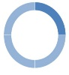
PAY QUARTILES

The graphics below shows the gender distribution at Lighthouse Schools Partnership when colleagues are placed into four equally sized quartiles based on pay.
Total Employee %:
Female 81.4%
Male 18.6%

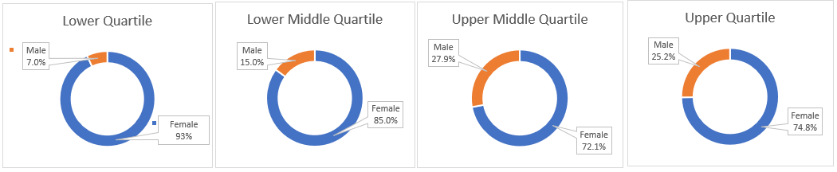
A message from Gary Lewis, CEO of Lighthouse Schools Partnership

The data in this report reflects the position on 31st March 2021, when the Trust was comprised of 24 schools, of which 3 are secondary and 21 are primary schools.

The Gender Pay Gap is defined as the difference between the mean (average) or median (actual midpoint) hourly rate of pay of male and female employees.

The Lighthouse Schools Partnership employs more female than male staff, which is consistent in the education sector for state schools and academies.

The underlying factor affecting the pay gap is that there are mainly female staff in support roles, such as dinner/lunchtime assistant roles, which fall within the lower quartiles. During the last year there has been a continued increase in representation within the upper quartile pay band for female employees and a slight decrease in the female representation in the lower quartile pay band.

The pay rates for staff are set nationally and are applied equally to all staff members. As an employer, we are committed to the principles of paying people equally for undertaking the same work, regardless of their gender. We continue to review our practices to identify and eliminate conscious or unconscious bias in appointments and staff development.

I confirm that this information has been prepared from our payroll data on the snapshot date of 31st March 2021, and fairly represents the Gender Pay Gap information for the Lighthouse Schools Partnership.

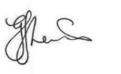
G J Lewis
We conﬁrm the data reported is accurate. In accordance with the Equality Act 2010 (Gender Pay Gap Information) Regulations 2017, The LSP is required to carry out Gender Pay Gap Reporting.

